Opioids
Impact Score
0 23 30
High dose use of opioids may result in serious, harmful symptoms or death.

Health Impacts  Increased risk of:  - Respiratory depression  - Death | Comparison  Opioid Overdose Deaths, Marion Co. vs. other locations, 2016  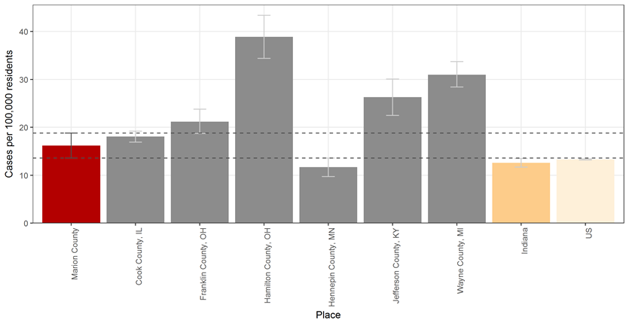  Source: CDC WONDER Fatal Drug Overdose
Treatment  - Medication Assisted Therapy (MAT) via Methadone, Naltrexone or Buprenorphine  - Cognitive-behavioral therapy  - Motivational enhancement therapy  - Inpatient and Residential treatment or intensive outpatient treatment  Source: WHO, Information sheet on opioid overdose & CDC Risk Factors for Prescription Opioid Abuse and Overdose | Trend  Marion Co. Opioid Overdose Deaths, 2010-2016  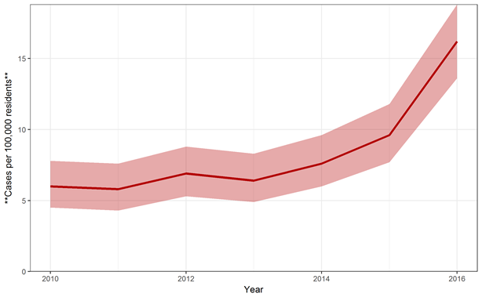  Source: CDC WONDER Fatal Drug Overdose

Risk Factors
- History of substance use disorder
- High prescribed dosage or multiple prescriptions
- Male gender or older age
- Mental health conditions
Source: WHO, Information sheet on opioid overdose & CDC, Risk Factors for Prescription Opioid Abuse and Overdose

Equity
Overdose Deaths by Drug Type, Marion Co. 2017
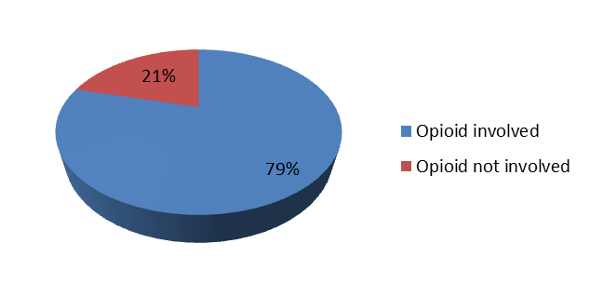
Source: Marion County Coroner’s Office Toxicology Data (of 406 overdose deaths with toxicology)
Naloxone EMS Runs by Age, Marion Co. 2013-2016
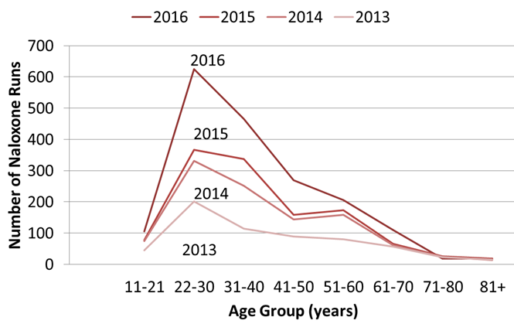
Source: I-EMS Naloxone Administration Data

